| **Team Number** | 08 | **Section** | 61 |
| --- | --- | --- | --- |
| **Team Members** | 1. Josh Medina 2. Aden Mengistie 3. Anh Nguyen 4. Steve Rubin | | |
| **Software Name** | Reflection | | |

# Introduction

## Objective

The objective of this document is to provide an in-depth understanding of the authentication and features of the Reflection software. This document will outline the functional requirements, class diagrams, state diagrams, and sequence diagrams; along with the mockups for the application. This document is intended for developers, testers, project managers, and stakeholders that are affiliated with the reflection software.

## References

Scene Builder - Gluon

[www.pexels.com/@jessbaileydesign/](http://www.pexels.com/@jessbaileydesign/) - Images

www.plantuml.com/ - Class Diagram tools

www.gituml.com/ - Class Diagram tools

## Acronyms and Abbreviations

N/A

# Software Overview

## Functional Requirements

**Authentication**

1. The First time logging in the user will be prompted to enter the default password.
2. First time user will be prompted to change password
   1. Provide default
   2. Enter new password
   3. Confirm password
   4. Enter security question
   5. Enter answer to security question
3. User can enter password to login to application
4. User shall be able to reset their password
   1. Answer the security question initially set up
   2. Enter the new password
   3. Confirm the new password
5. Password shall be stored in a file as plain text
6. Users shall be able to logout and be directed to the home page

**Application’s Features**

1. User shall be able to create new journal entries
2. The user will be able to enter the following information to their entry
   1. An **optional** title
   2. Current date-time (date-picker that picks the current date-time by default, but it shall be editable)
   3. The context (main text area for writing the journal)
3. User shall be able to save the journal entry
4. User shall be able to cancel any entry to return to the homepage
5. Users shall be able to search for a journal entry based on a substring in the context or in the title
6. The user shall be able to view an old journal entry **after searching for it**
7. The user shall be able to edit an old journal entry **after searching for it**
8. The user shall be able to delete an old journal entry **after searching for it.**

# Detailed Design

## UML Class Diagrams

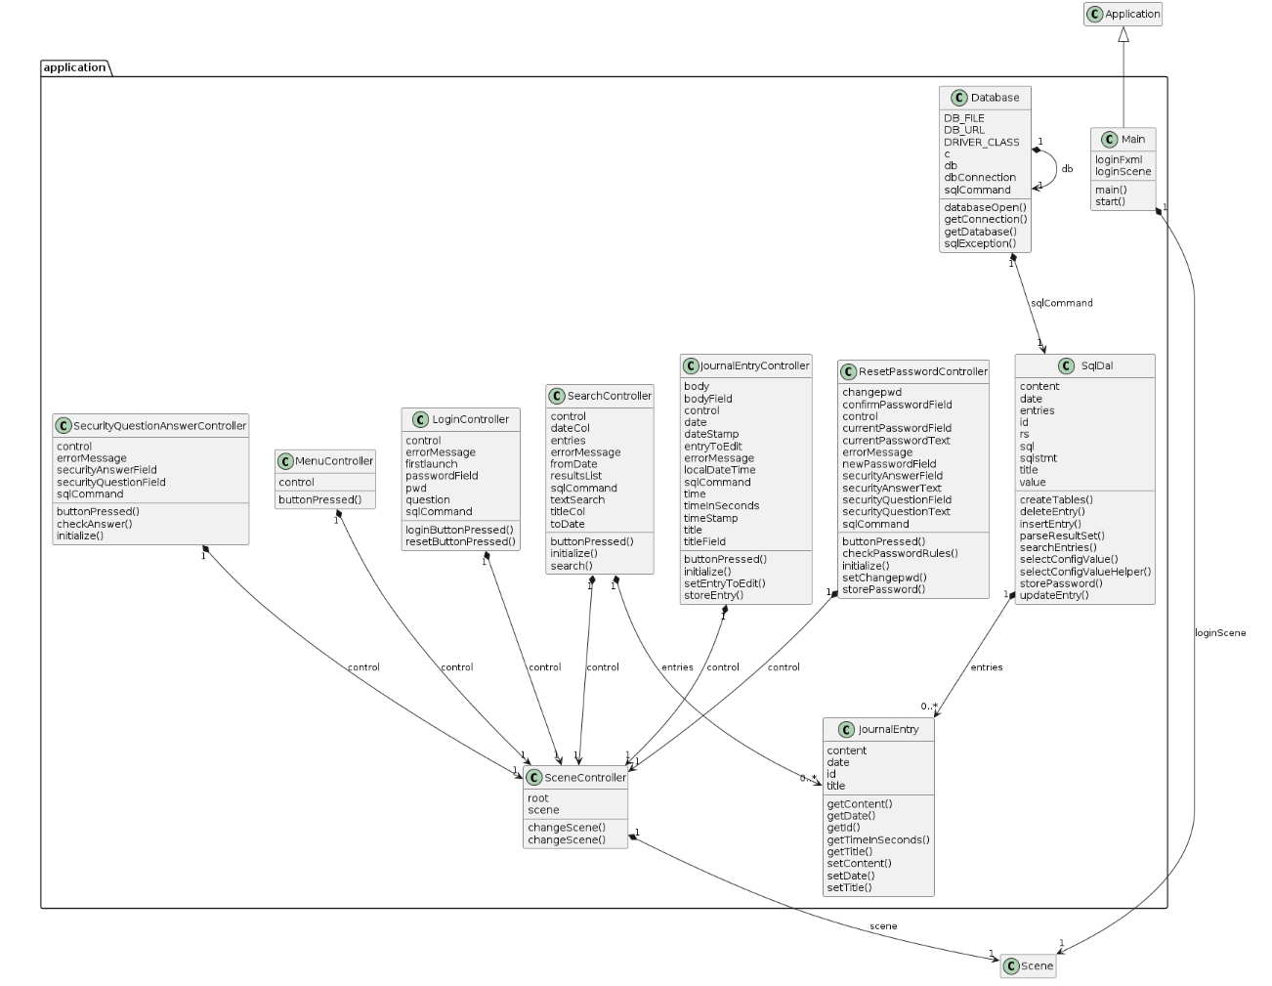

## UML Sequence and/or State Diagrams

**Sequence Diagram**

**Login**

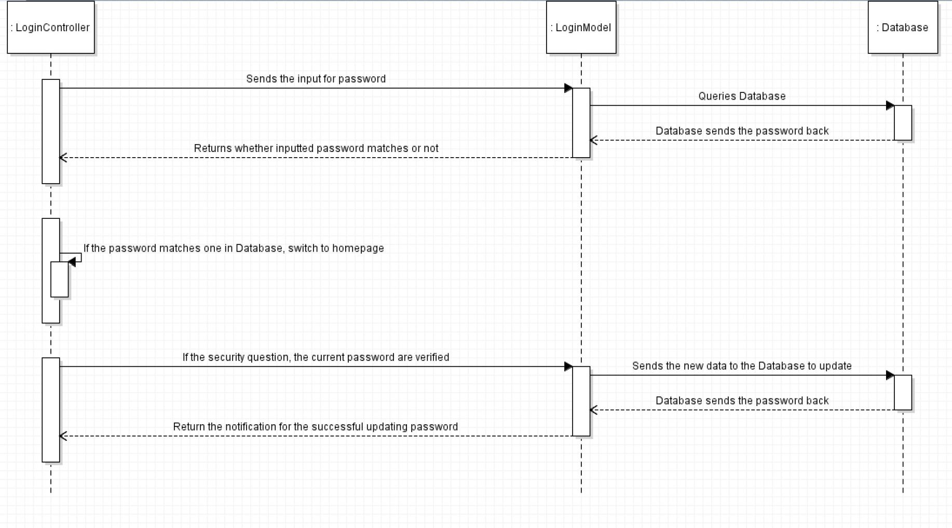

**Search and Delete Journal Entry**

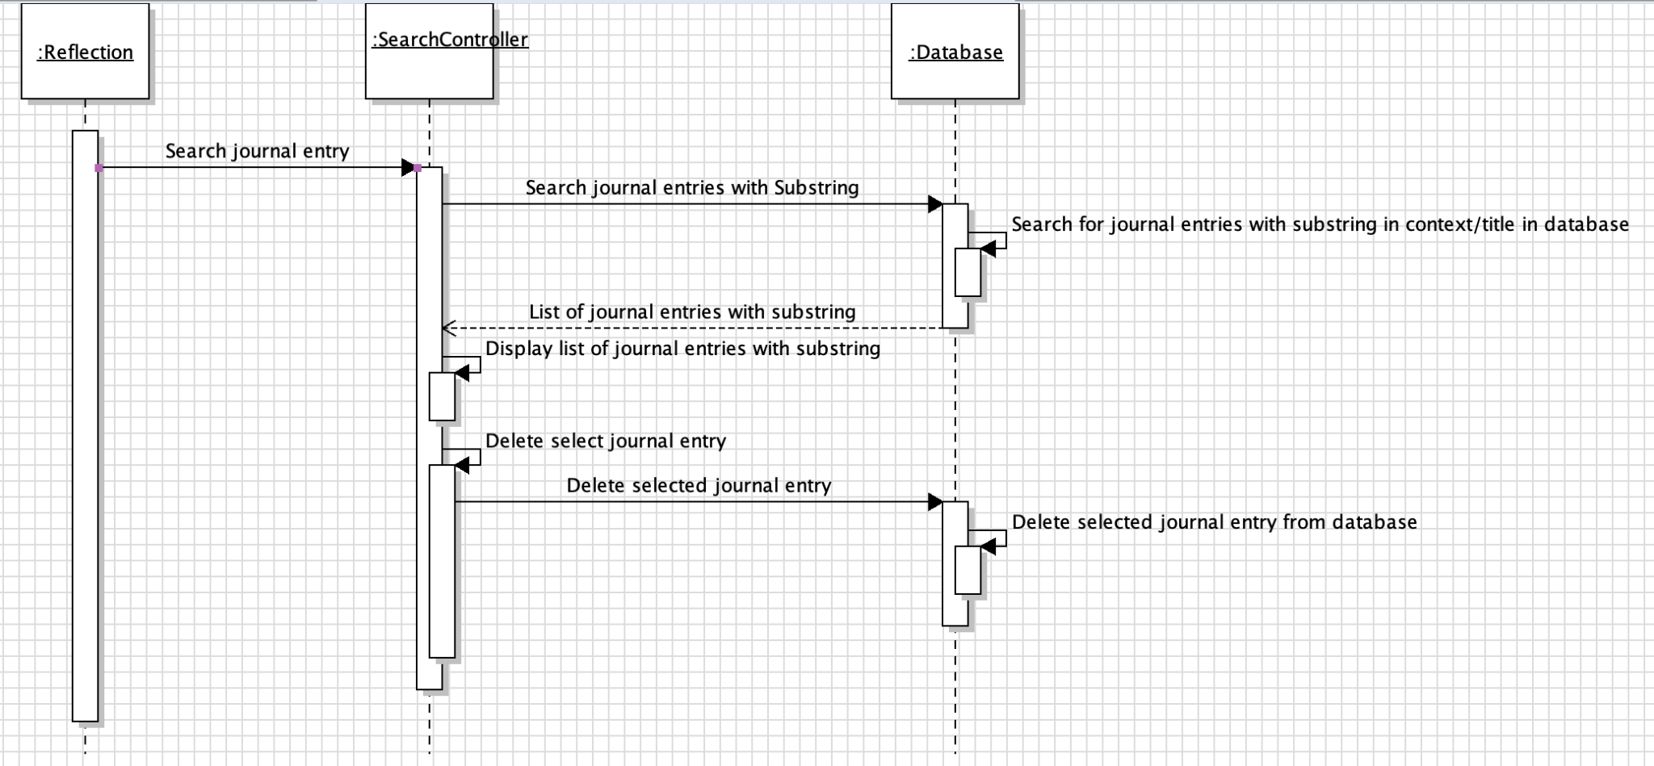

**State Diagram**

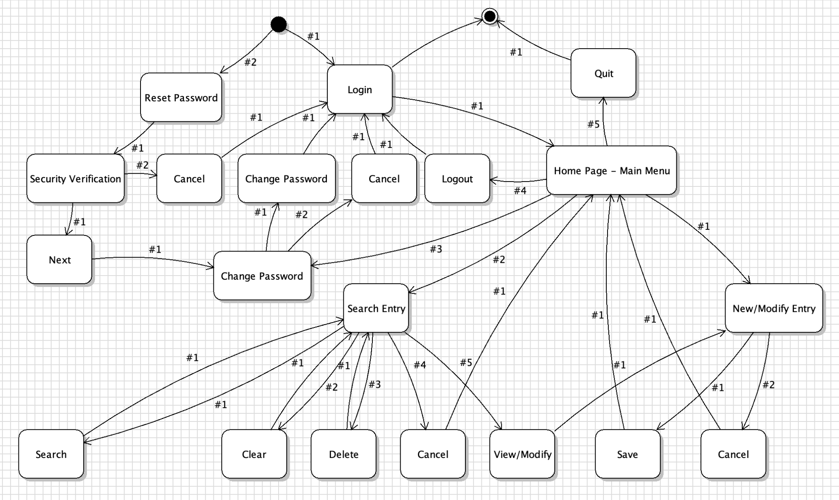

## Mockups

Login Page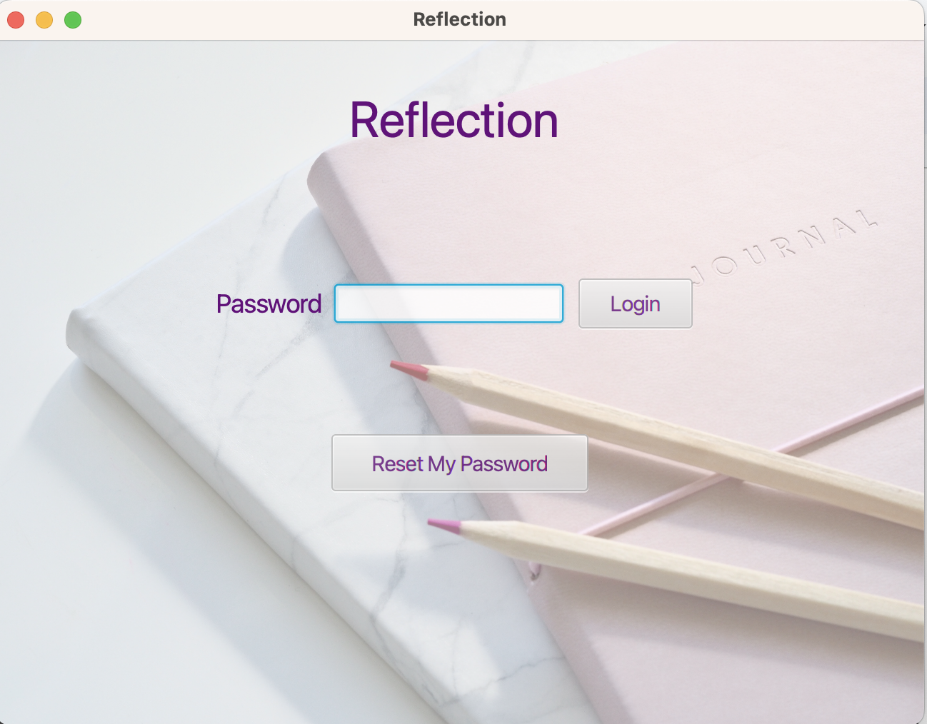

Change Password Page

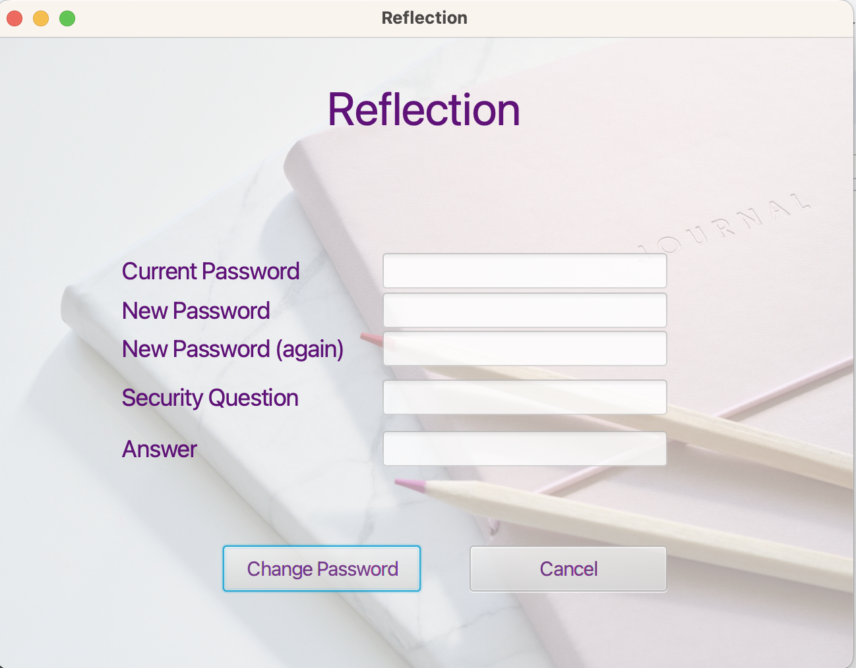

Journal Entry Page

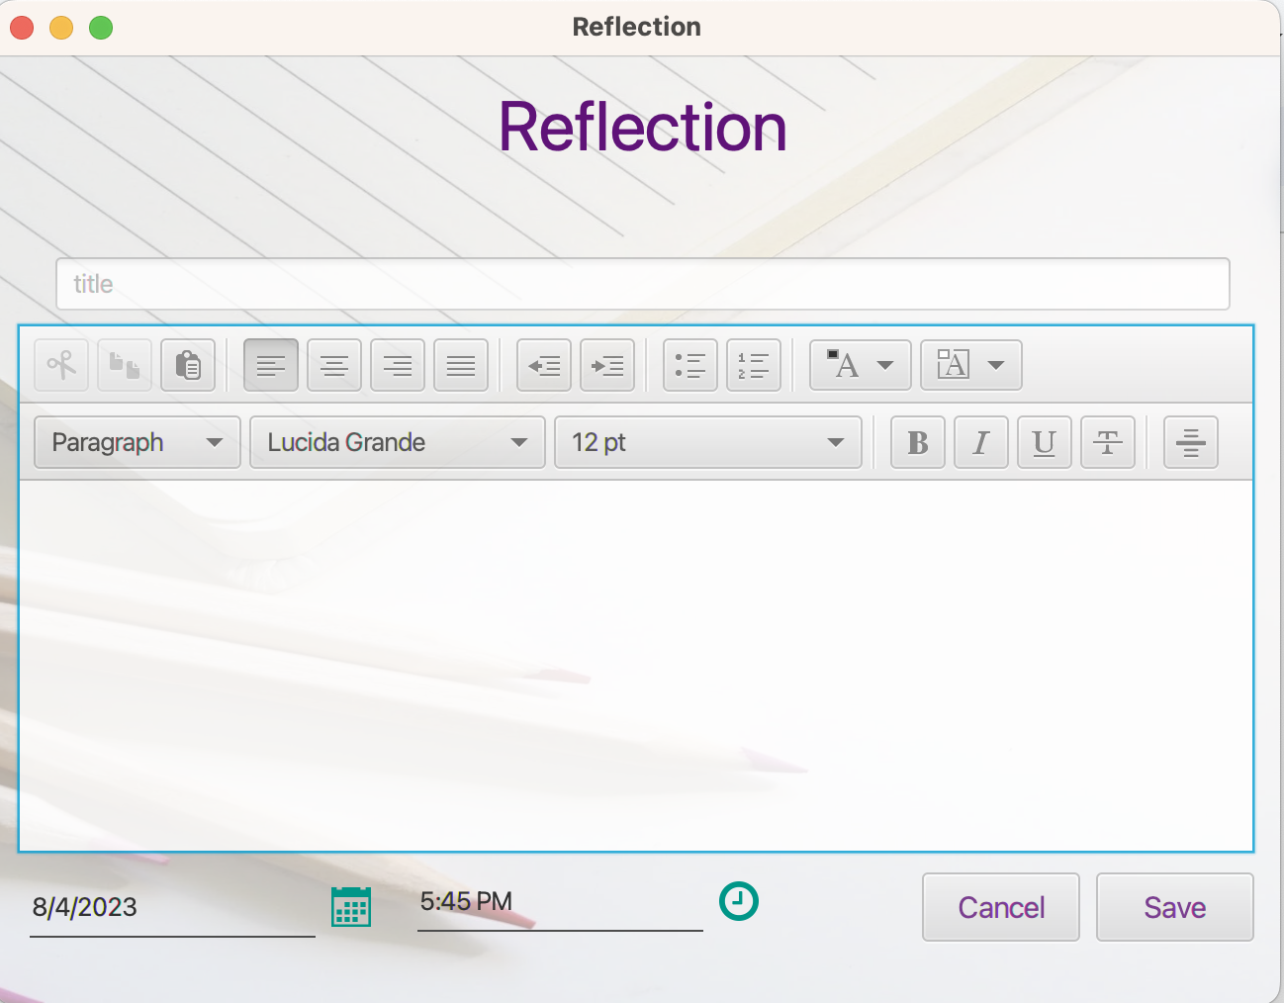

Home Page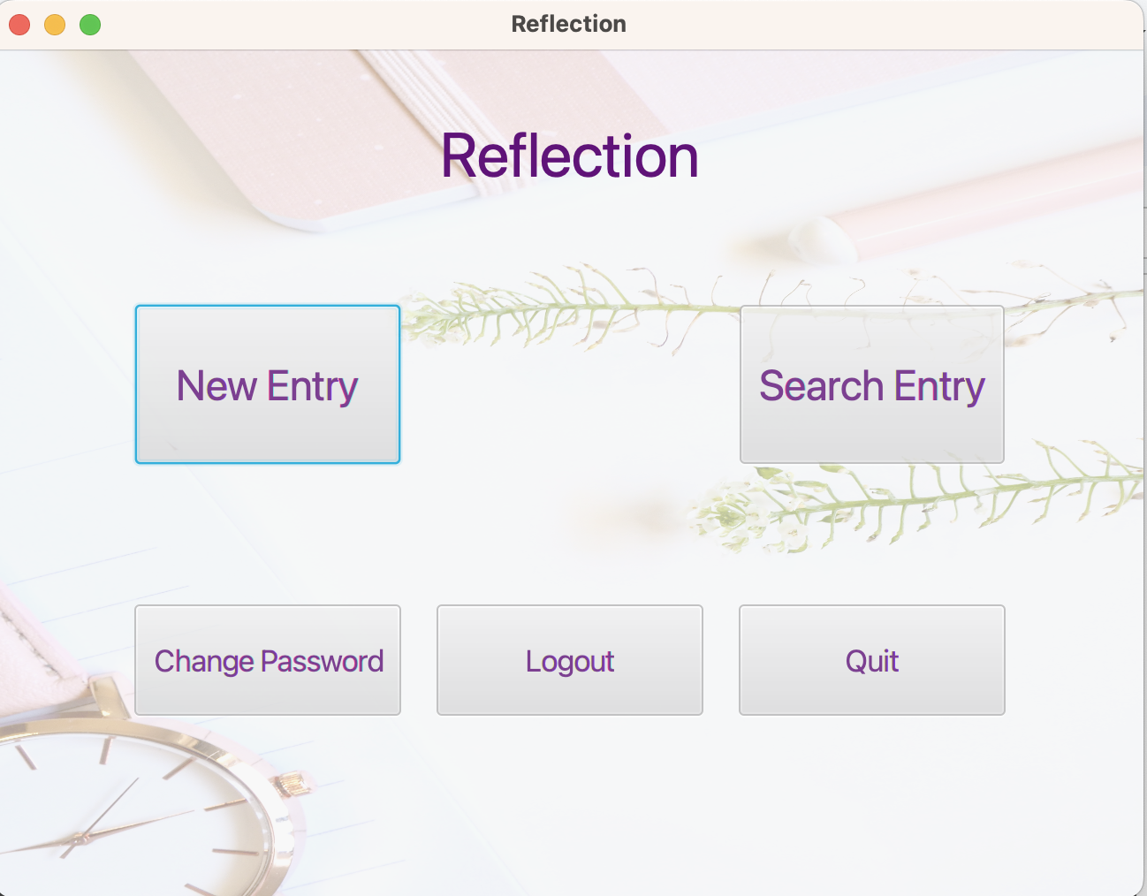

Search Page